In core php, application starts from **index.php** file. In Laravel it starts from **index.php** file too. But it contains code to bootstrap the Laravel.

* This line makes the application load the app from the app.php file.



* If we go to the **app.php** file we can see it creates a new instance of application class.

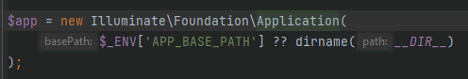

* The **application** class is a huge class which creates the application framework. This extends **Container.** Three important array constants in this class are
  + **serviceProviders** it is an array. It contains the services that is provided in the application.
  + **loadedProviders** it contains the loaded services.
  + **deferredServices**